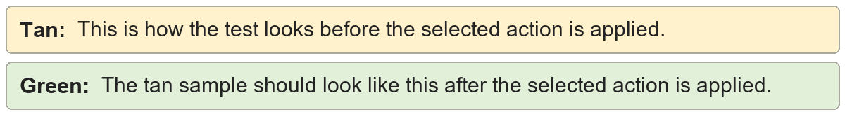
Remove comments | Shared review sentence.
Remove comments | Shared review sentence.

Accept tracked changes | Shared review sentence.
Accept tracked changes | Shared review sentence.

Minimal author cleanup | Shared review sentence.
Minimal author cleanup | Shared review sentence.

Normal author cleanup | Shared review sentence.
Normal author cleanup | Shared review sentence.

Broad author cleanup | Shared review sentence.
Broad author cleanup | Shared review sentence.

